Gathering to remember lost miners
- By Matt Combs Register-Herald Reporter
- 6 hrs ago (July 2018)

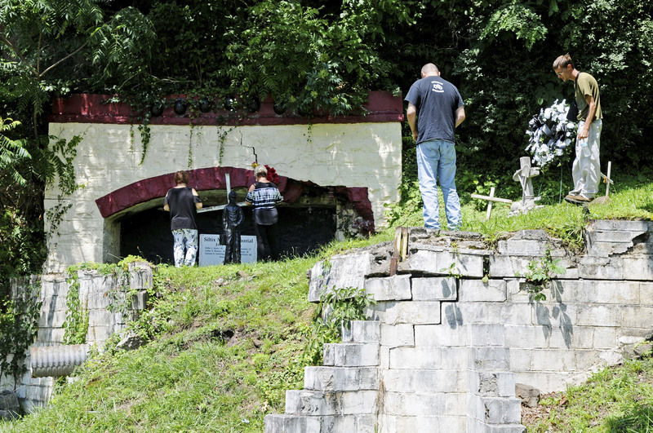

Chris Jackson/The Register-HeraldPeople look over the memorial set up at the entrance to the Siltix Mine, which exploded in 1966, killing seven and injuring two, during a remembrance in Mount Hope on Monday.

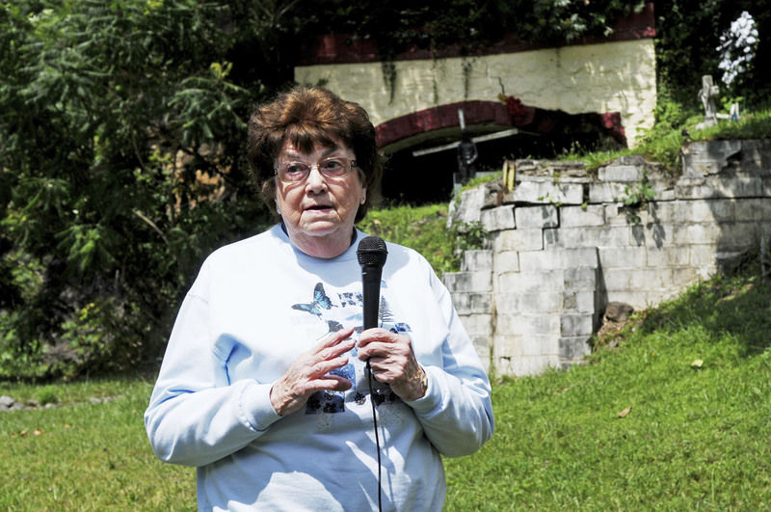

Pat Legg, from Beckley, whose husband, Don Legg was a survivor of the Siltix Mine Disaster, speaks during a remembrance at the entrance to the mine site in Mt. Hope on Monday. Seven people died in the 1966 explosion, two were injured and 39 escaped. (Chris Jackson/The Register-Herald)

Chris Jackson/The Register-HeraldRita Daniels, from Maple Fork, whose father died in the Siltix Mine of the New River Co. disaster in 1966 when she was 10 days old, speaks during a remembrance as Thomas Brown and Brenda Troitino look on at the site of the entrance to the mine in Mount Hope on Monday.
Fifty-two years to the date after an explosion ripped through the Siltix mine in Mount Hope, friends, family and even a couple survivors gathered near the highly visible roadside mine portal to remember those who were lost.
“I remember that day,” said Pat Legg, whose husband was inside the mine when it exploded.
Legg was driving through Mount Hope on the way to an errand when she noticed a large crowd gathered at the mine portal.
When she threw her car into park, a man told her that she would have to move — he said there was an explosion in the mine and everyone was dead.
Getting out of the car, Legg ran to the doctor to see if the report was true. She was told her husband had survived but was injured.
Legg then asked about a cousin, Luke Bowyer, who was also in the mine.
Bowyer was one of seven men killed.
l l l
Brenda Troitino remembers the day as well, though she had no relatives in the mine.
In between her junior and senior year of high school — the summer of 1966 — Troitino remembers the community coming together during a trying time.
“I didn’t know anyone that was in the mines, but it was a devastating time,” she said. “Mount Hope is such a close-knit, and always has been, a very close-knit community. What affected one, affected everybody.”
It was Troitino’s idea to start an annual remembrance day after seeing similar events for the more recent Upper Big Branch disaster.
A member of Mount Hope Heritage and Hope, Troitino tried to organize an event for the 50th anniversary in 2016, but couldn’t get one set up until last year.
l l l
A person who is happy to see the event continue is Ross Painter.
Painter, a miner with 35 years’ experience, was inside the mine when the explosion occurred, working with another miner closer to the entrance.
They had finished their work and were waiting for a ride out of the mine when they heard a noise coming from farther inside the mine.
“We thought it was a big slate fall,” Painter said.
After learning of the explosion, Painter and the other miner working with him walked over a mile out of the mine.
“When we came out of the mine, this whole thing down here was plumb full of people,” Painter said of the area near the mine portal. “I had to ask people to move so I could go home.”
The experienced miner knew three of the miners killed well, and though mining could be dangerous, he was appreciative of what the profession gave him.
• • •
Another longtime miner at the event also shared his recollection.
Wiley Cullop was working farther into the mine, in an area that was adjacent to the explosion.
“I knew it was an explosion,” Cullop said. “At least I thought it was.”
Trying to find a way out, Cullop and his crew attempted to walk out, until they decided to build a curtain wall to try to keep out the fumes.
Staying behind the curtain until help arrived, the men began their walk out with Cullop and fellow miner Gene Hall. They walked toward the coal face to look for other survivors.
Cullop began to notice the gas affecting him while he was nailing up curtains.
“Pretty soon I couldn’t raise them,” Cullop said of his arms.
Seeking low ground, the experienced miner lay down in a pool of water to try to get away from the fumes.
“I came to in the Oak Hill hospital,” Cullop said. He said he was very fortunate to escape.
While Cullop said he has done his best to move on from the disaster, he said he is happy to see the event take place for the children of those who were lost that day.
• • •
Rita Daniels is one of those children.
Now in her 50s, she was only 10 days old when her father, Robert Daniels, passed away in the disaster.
Though she said the only things she knows about her father are things that people have told her, Daniels believes in keeping her father’s memory alive.
“I think about him every day,” she told the gathered crowd.
Daniels is happy that the event is ongoing.
“You have no idea how much I appreciate that you all are giving recognition to these seven men,” Daniels said.
• • •
For Troitino, there is no other option but to remember.
“We want to preserve the heritage of this area,” she said of her group.
While many look toward the future, Troitino said that without knowing your past, you won’t know anything in the future.
Troitino announced that Mount Hope Heritage and Hope will attempt to erect a historical marker at the mine portal.
The announcement quickly gained its first donations, with the National Coal Heritage Area promising to give 50 percent of the cost to see the marker become a reality.
That marker will remember the seven men: Luke Bowyer, James McGuire, Robert Daniels, Howard Morris, Hubert Dowdy, Dallas Ayers and Clarence Cummings.
Until then, Troitino said that her group will maintain July 23 every year as a day for remembering the mine disaster.
Those wishing to donate to the marker can mail their donations to Mount Hope Heritage and Hope, P.O. Box 230, Mount Hope, WV 25880.

